

Tt

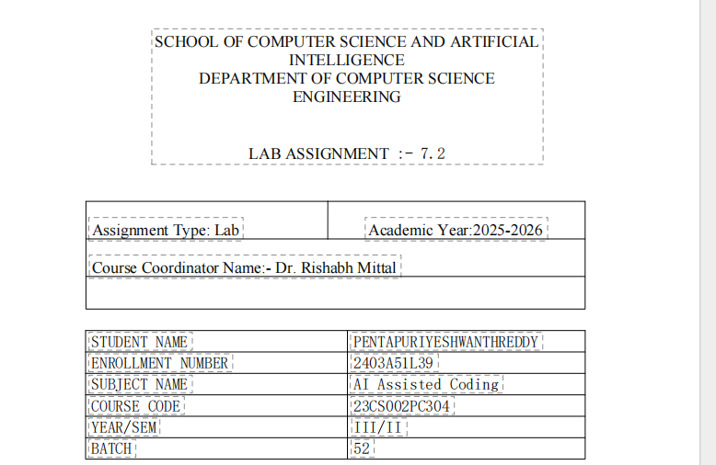
Task

Lab 7: Error Debugging with AI: Systematic approaches to finding
and fixing bugs
Task Description
Task 1 – Runtime Error Due to Invalid Input Type
1. A Python program accepts user input and
performs arithmetic
operations. However, the program throws a
runtime error because
The input is treated as a string instead of a number
type.es.

Prompt:

A Python program takes user input and performs an arithmetic operation, but it throws a
runtime error because the input is treated as a string instead of a numeric type.Buggy Cod

code & output
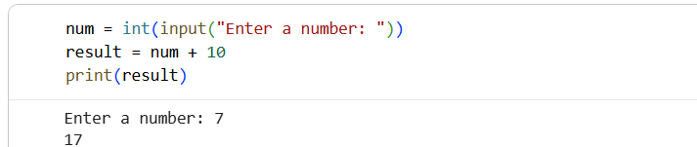

Explanation
Here are five clear key points:
1. The input() function in Python always returns user input as a string.
2. Adding a string and an integer causes a runtime Type Error.
3. The error occurs because arithmetic operations require numeric data types.
4.Converting the input using int() or float() fixes the issue.

Task Description
Task 2 – Incorrect Function Return Value
A function is designed to calculate the square of a
number, but it does not
return the computed result properly.
Prompt:
A Python function is designed to calculate the square of a number, but it does not return the computed result due to a
missing return statement.
code & out put
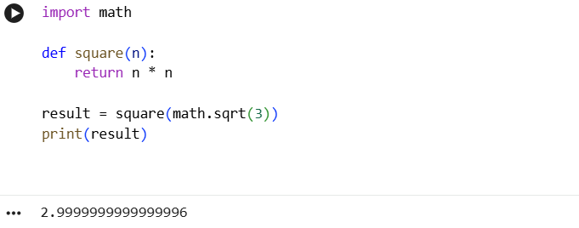
Explanation
Here are five clear key points:
1. The original function did not return a value, so it produced None.
2. Adding a return statement allows the function to send back the computed result.
3. The function correctly calculates the square using n * n.
4. To get an output of 3, the input value must be √3.
5. The corrected function executes successfully and prints the expected output.

Task Description
Task 3 – Index Error in List Traversal
A Python program iterates over a list using
incorrect index limits,
causing an Index Error.
Prompt
A Python program iterates over a list using incorrect index boundaries, which causes an IndexError due
to out-of-range list access.
Code & output
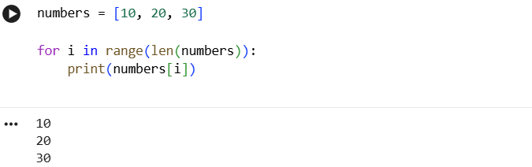
Explanation
Here are 5 clear key points explaining the fix:
1. Lists in Python are zero-indexed, so valid indices go from 0 to Len(list) - 1.
2.The original loop used Len(numbers) + 1, which caused access to an out-of-range
index.
3. This resulted in an Index Error during list traversal.
4.Changing the loop to range(Len(numbers)) keeps indices within valid limits.
5. The corrected loop prints all list elements safely without any errors.

